Nama: Haddy Firdaus

NIM: 1207070050

TUGAS LATIHAN CRUD SQFLITE

* 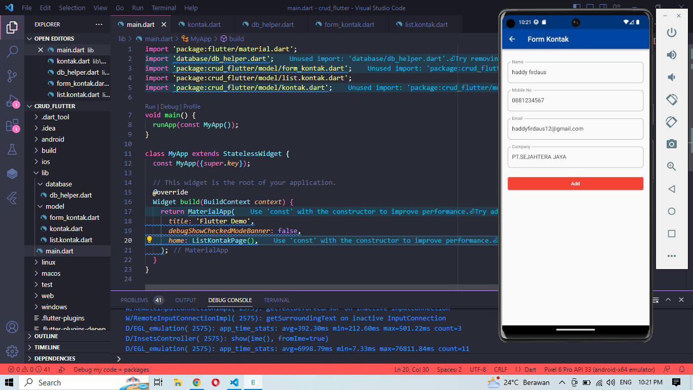Tampilan Form Kontak
* 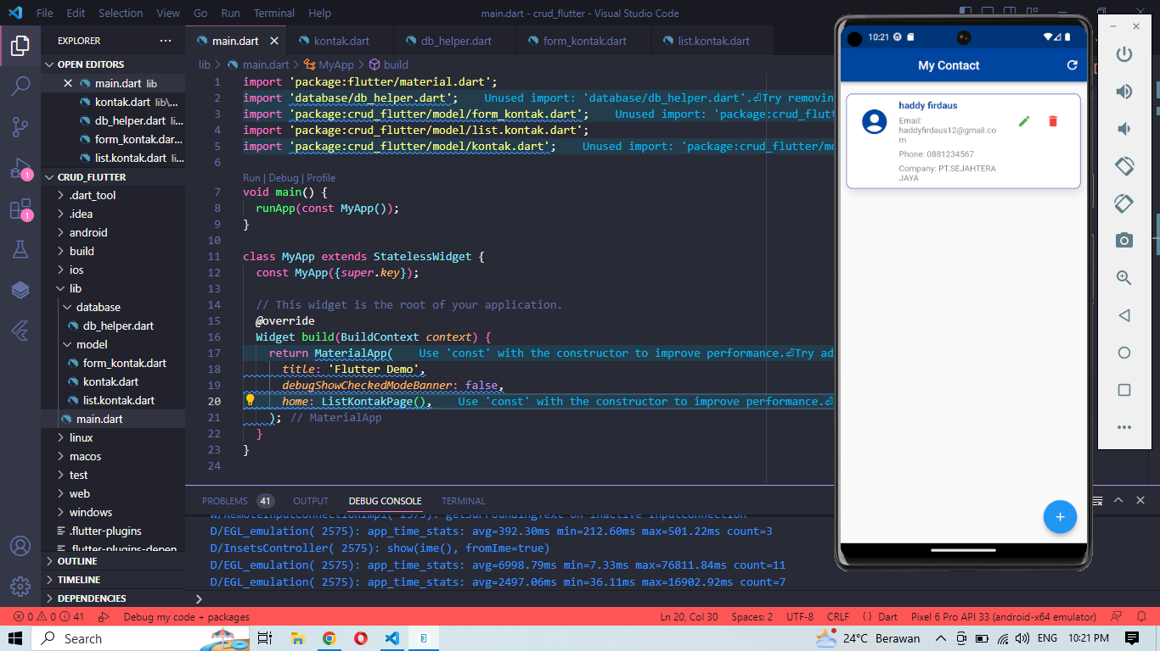Tampilan My Contact

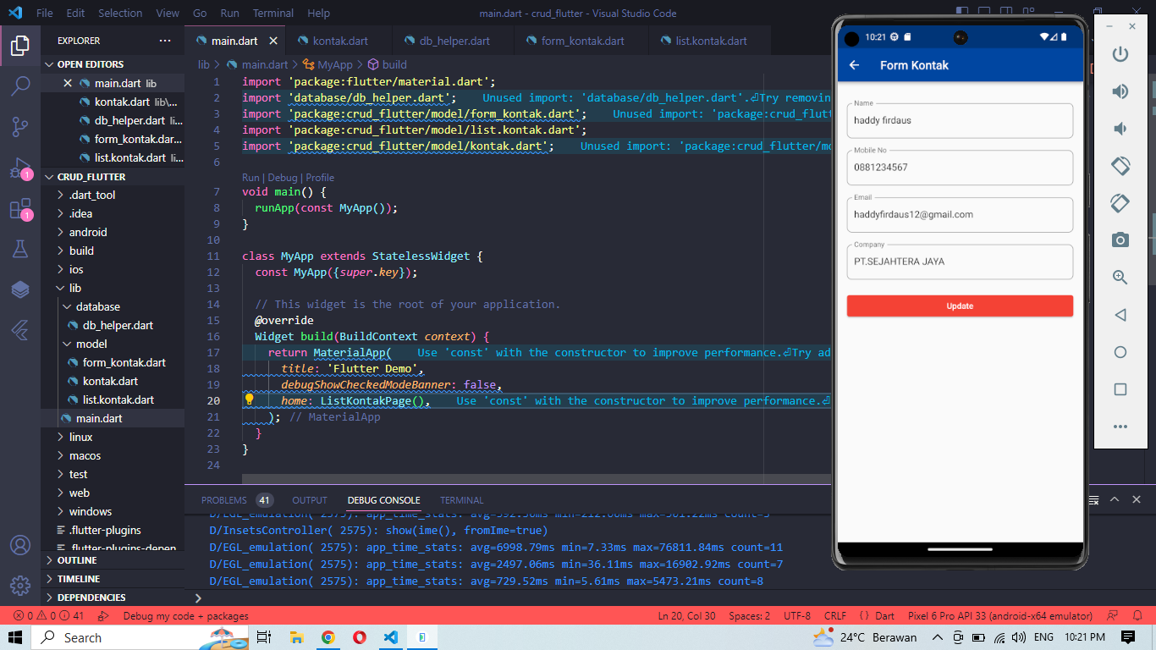

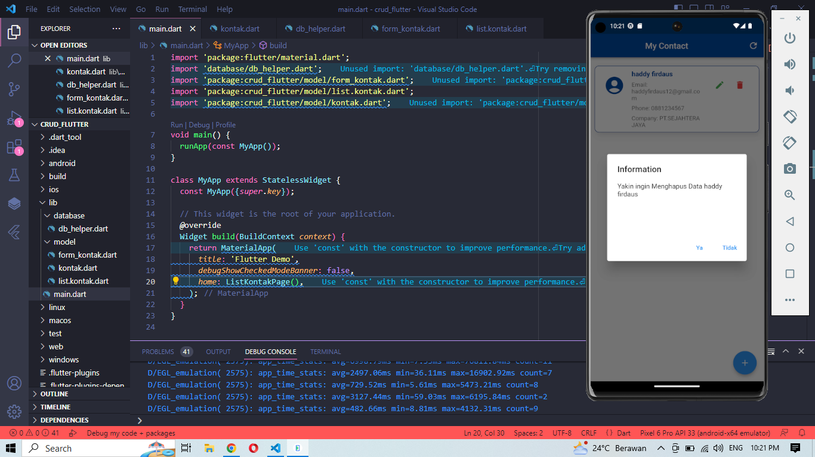

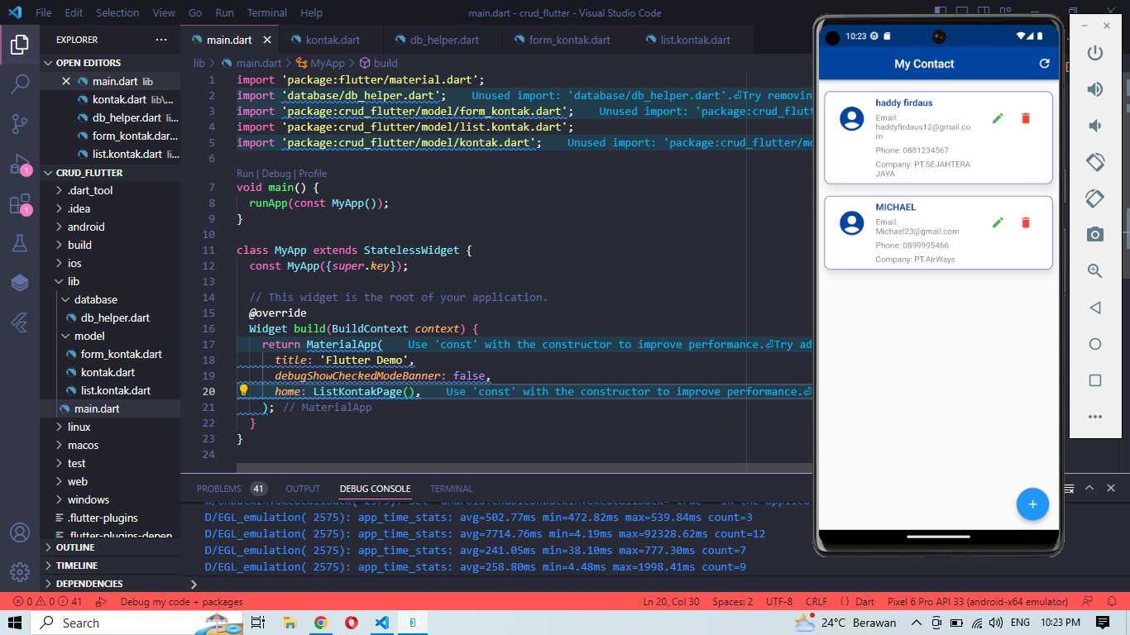

* Link Github

https://github.com/HaddyFirdaus/1207070050_HaddyFirdaus_LATIHANCRUDSQFLITE